Status of This Document

Version History
Ver. No. | Date | Revised By | Description | Filename
1.0 | May 4, 2006 | Joel Matsumoto | First draft for Housecleaning detail design | House Cleaning Detail Design v1.0.doc

Table of Contents

1. Status of This Document 2
1.1. Version History 2
2. Table of Contents 3
3. Introduction 5
3.1. Overview of the Affected Classes 5
3.2. Overview of Affected Configuration Files 6
4. Piazza Commons Mail Package 7
4.1. SmtpMail.java 7
4.1.1. Constructor 7
4.1.2. public void send 7
4.1.3. public void close 7
4.1.4. public void connect 7
4.1.5. private SMTPMessage composeMessage 7
4.1.6. private Transport getTransport 7
4.2. SmtpMailProperties.java 7
4.2.1. Setter Methods 7
4.2.2. Getter Methods 7
4.3. SmtpMailException.java 7
5. Housecleaning 8
5.1. Module Group 8
5.1.1. plugin.xml 8
5.1.2. admin.module-group.xml 8
5.1.3. admin.main.core.module.xml 8
5.1.4. admin.properties.xml 8
5.1.5. admin.logger.xml 8
5.1.6. admin.main.scheduler.module.xml 8
5.2. AdminMainProcessor.java 8
5.3. Scheduler Active Task 8
5.3.1. Class Constants 8
5.3.2. public void execute 9
5.3.3. private boolean checkNotExceeded 9
5.3.4. private boolean checkStartTime 9
5.3.5. private Transaction cleanAS2 9
5.3.6. private Transaction cleanEBMS 9
5.3.7. private void commitTx 10
5.3.8. private SMTPMessage createMessage 10
5.3.9. private AdminProperties loadProperties 10
5.3.10. private void rollbackTx 10
5.3.11. private void sendMail 10
5.3.12. private void setDefaultProperties 10
5.3.13. private void setEndStatus 10
5.3.14. private void setStartStatusAndTime 10
5.3.15. private void stackTraceToLog 10
5.4. SchedulerTaskList.java 10
5.5. AdminProperties.java 11
5.6. AdminPropertiesException.java 11
5.7. PropertiesPageletAdaptor.java 11
5.8. CorePropertiesPageletAdaptor.java 11
5.9. DAO of EbMS and AS2 11
5.9.1. public List findMessagesBeforeTime 11
5.9.2. DAO configuration files of EbMS and AS2 11
6. Message History Enhancements 12
6.1. DAO of EbMS and AS2 12
6.1.1. public List findMessagesByTime 12
6.2. The XSL pages 12
7. Housecleaning Control Flow 13
8. References 15

Introduction
This document is intended to clearly show the details of the implementation of the Hermes 2 Housecleaning and Message history enhancements.

Overview of the Affected Classes
The affected classes will be located in the 4 following projects: Commons, Corvus.Main.Admin, Corvus.AS2 and Corvus.EbMS.

Commons
hk.hku.cecid.piazza.commons.mail
SmtpMail.java
SmtpMailProperties.java
SmtpMailException.java
Corvus.Main.Admin
hk.hku.cecid.piazza.corvus.core.main.admin
AdminMainProcessor.java
hk.hku.cecid.piazza.corvus.core.main.admin.hc.module
SchedulerTask.java
SchedulerTaskList.java
hk.hku.cecid.piazza.corvus.core.main.admin.hc.util
AdminProperties.java
AdminPropertiesException.java
hk.hku.cecid.piazza.corvus.core.main.admin.listener
PropertiesPageletAdaptor.java
CorePropertiesPageletAdaptor.java
Corvus.AS2
hk.hku.cecid.edi.as2.dao
MessageDAO.java
MessageDataSourceDAO.java
Corvus.EbMS
hk.hku.cecid.ebms.spa.dao
MessageDAO.java
MessageDataSourceDAO.java

Overview of Affected Configuration Files
The affected XML and XSL files.

Corvus.Main.Admin
spa/
plugin.xml
conf/hk/hku/cecid/piazza/corvus/core/main/admin
conf/
admin.logger.xml
admin.main.core.module.xml
admin.main.scheduler.module.xml
admin.module-group.xml
admin.properties.xml
ui/
properties.xsl

Corvus.AS2
spa/hk/hku/cecid/edi/as2/conf/as2.dao.xml
Corvus.EbMS
spa/conf/hk/hku/cecid/ebms/spa/conf/DAOMessage.xml

Piazza Commons Mail Package
This package was developed to provide easier use of the javax.mail SMTP classes.

SmtpMail.java
The SmtpMail class wraps a mail session specified for smtp transport and message.

Constructor
The constructor allows specification of SSL or non-SSL as well as a SmtpMailProperties object to use.

public void send
This method allows sending of a message or string. If a string is given, a SMTP message will be instantiated automatically. This method uses an SMTP transport object returned by the associated session.

public void close
This method closes the transport connection created. AN exception is thrown if any error occurs.

public void connect
This method connects the SMTP transport object returned by the associated session. This should be called before sending any messages. An exception will be thrown if any error occurs while attempting to connect.

private SMTPMessage composeMessage
A private method for composing a message given a String.

private Transport getTransport
Return a transport from the session with the given provider.

SmtpMailProperties.java
An business object wrapping the SMTP properties for easier access to the SMTP mail properties.

Setter Methods
Set the SMTP property to the given value.

Getter Methods
Get the SMTP property.

SmtpMailException.java
This simple exception is used by the SmtpMailProperties class to indicate an error has occurred.

Housecleaning
The housecleaning module affects a number of classes. It itself is a new component of the module group associated with the Corvus.Main.Admin plugin. To implement it, a module group must first be implemented for this plugin.

Module Group
The module group is loaded by corvus on startup.

plugin.xml
Two main parts were added to this file. Adding the module group configure file location and additional plugins to load (EbMS and AS2).

admin.module-group.xml
The admin module group that specifies the different modules associated with the group. The two modules are the admin core module and the housecleaning active task module.

admin.main.core.module.xml
The configuration file for the admin core module. There are two components to this module. The logger and the properties tree which is loaded using the admin.properties.xml.

admin.properties.xml
This is the admin properties that are to be loaded when the admin core module is loaded. Currently, the only properties in the file are the properties needed for the housecleaning.

admin.logger.xml
The logger configuration file for the log4j component to write to admin.main.log.

admin.main.scheduler.module.xml
This is the housecleaning active task module configuration file. The active task specified by this file will be run every 10000 ms.

AdminMainProcessor.java
This is the plugin loader for the admin main module group. It is used by corvus to load this plugin as well as deactivate it.

Scheduler Active Task
This is the heart of the house cleaning task and will perform all the operations from checking for the time to run to running the actual house cleaning.

Class Constants
This class has many constants which are described in detail in the code. Mainly to specify the default formats as well as the formatting of the time.

public void execute
This is the inherited method from the ActiveTask interface. It is the method that is called when the task is called. This is also the highest level of the task. All the exceptions will be caught here and processed accordingly as well as logged. The correct response will also be applied according to the situation. There are 6 main routes of execution.
- House cleaning is turned off or the ‘on’ property is not a valid Boolean. The class will just return control to the calling class which is the active task manager.
- The house cleaning is turned on but the run date has not been reached yet. The class will return.
- The house cleaning is turned on but one of the required properties is invalid or missing. House cleaning will set the default properties and reschedule house cleaning for a new day. If the email and SMTP server is set, it will send out notification.
- The house cleaning is turned on and the run date has passed. The run time window has not expired yet. Housecleaning will commence. An exception is thrown and caught. The error will be logged and if the email and SMTP server is set, it will send out notification.
- The house cleaning is turned on and the run date has passed. The run time window has not expired yet. Housecleaning will commence. No exception is thrown. The success will be logged and if the email and SMTP server is set, it will send out notification.
- The house cleaning is turned on and the run date has passed. The run time window has expired yet. House cleaning will be scheduled to the next coming date and the error will be logged. If the email and SMTP server is set, it will send out notification.
- If an exception is thrown when sending the email out, the error will be logged into the file.

private boolean checkNotExceeded
Checks to see whether the time has exceeded the run time window and returns a boolean depending on the result. Return true if it is not exceeded.

private boolean checkStartTime
Checks to see whether the current time has passed the run time. If so, it will return true.

private Transaction cleanAS2
This method cleans the AS2 database by purging all messages older than the parameter time. The function uses the DAO and DVO of the AS2 plugin. It returns a transaction so that the changes can later be committed permanently. If a DAO exception is thrown while cleaning, it will log the error and throw a new Exception.

private Transaction cleanEBMS
This method cleans the EbMS database by purging all messages older than the parameter time. The function uses the DAO and DVO of the EbMS plugin. It returns a transaction so that the changes can later be committed permanently. If a DAO exception is thrown while executing, it will log the error and throw a new Exception.

private void commitTx
This method commits the transactions in the Transaction[]. If an exception is thrown while committing, it will log the error and throw a new Exception.

private SMTPMessage createMessage
This method creates the email message and returns the new SMTPMessage object.
The header will have a tag to indicate success or failure. [Success] or [Failed].
It will set the property from to the same address as the recipient. The Personal name will be set to Hermes2 Admin to indicate that it is from Hermes2.
The content will include the date as well as the status for the last update and the next run date. If an error occurred, a general reason for failure will also be appended.

private AdminProperties loadProperties
A simple method which creates a new AdminProperties object using the admin core module properties and returns it.

private void rollbackTx
Roll back the transactions in the Transaction[]. If there is an exception when rolling back, it will log the error and throw a new Exception.

private void sendMail
Sends the mail to the address specified in the AdminProperties object. Formatting of the message will be done by the createMessage method. If an exception is thrown by the createMessage method or anywhere while trying to send the message, it will log the error and throw a new Exception.

private void setDefaultProperties
This method sets the default properties if the property is missing or invalid. It will ensure that the required properties are set and also set the next run date.

private void setEndStatus
This method sets the end status depending on the boolean parameter.

private void setStartStatusAndTime
This method sets the start status (processing) as well as the next run date.

private void stackTraceToLog
This method prints out the stack trace of the given exception to the admin.main.log.

SchedulerTaskList.java
This class just returns a list containing an instance of the SchedulerTask.

AdminProperties.java
This class is used to wrap and perform some error handling on the admin properties. If a property is null, it will throw an exception. For details, see the comments in the code.

AdminPropertiesException.java
This class is used to identify an exception originating from the AdminProperties class.

PropertiesPageletAdaptor.java
This class was refactored so that the JVM properties adaptor would not display the same as the core properties page. Namely, the centre source was factored into a protected method.

CorePropertiesPageletAdaptor.java
A method was added to this class to add the housecleaning interface and logics. The logic is similar to the properties section. There is checking to make sure the required fields are filled before saving to the file. Refer to the comments in the code for more details.

DAO of EbMS and AS2
A method was added to both the DAO interface and DataSourceDAO implementation.

public List findMessagesBeforeTime
This method returns a list of messages before the time indicated in months. In other words, the parameter indicates the number of months previous to the current time. The list will contain all messages older than the number of months given.

DAO configuration files of EbMS and AS2
A new finder statement with a SQL query statement was added to each configuration file. This statement retrieves all messages with a time stamp older than the wildcard ?.
<parameter type="finder" name="get_all_before_time" value="select * from Message where time_stamp &lt; ?" />

Message History Enhancements
The goal of the message history enhancement is to allow the user to view messages within a certain time frame from the current date.

DAO of EbMS and AS2
Like the housecleaning, a method was also added to the DAO interface and DataSourceDAO implementation. Unlike the housecleaning though, no new SQL query statement was needed as all the logic is handled within the method. This is achieved by using an existing method to retrieve a list of data. The method used is findMessagesByHistory.

public List findMessagesByTime
This method returns all messages within a certain time period. Unlike the housecleaning method, this will return all entries newer than the specified number months.

The XSL pages
For the XSL page for both EbMS and AS2 plugins, almost identical changes were made. A new drop down selection was added which has the options, {“All”, “1 month”,”3 months”, “6 months”}. The default is “All”.

Housecleaning Control Flow
The flow of control for housecleaning is quite simple. The user can access the configuration through the admin pages and update as necessary. The admin pagelet adaptor will write the properties to the file. A second thread (SchedulerTask) will run in the background and keep checking to see if housecleaning needs to be performed or not.
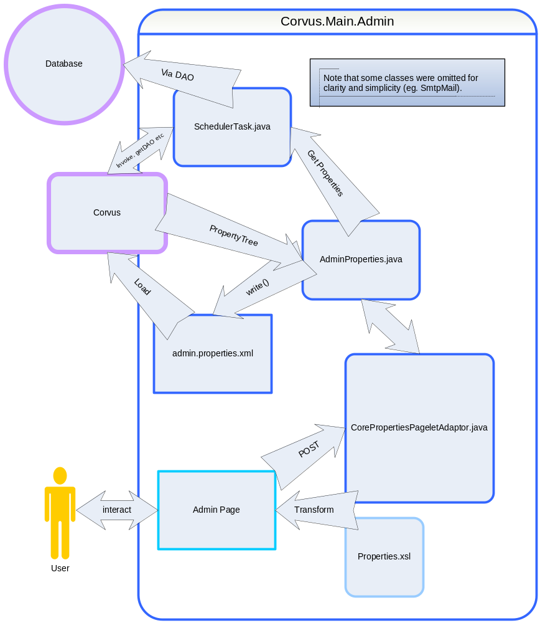

References

